SETTING UP THE APPLICATION ENVIRONMENT CREATE IBM CLOUD ACCOUNT

|  |  |
| --- | --- |
| **DATE** | 12 November 2022 |
| **TEAM ID** | PNT2022TMID10872 |
| **PROJECT NAME** | Inventory Management System for Retailers |

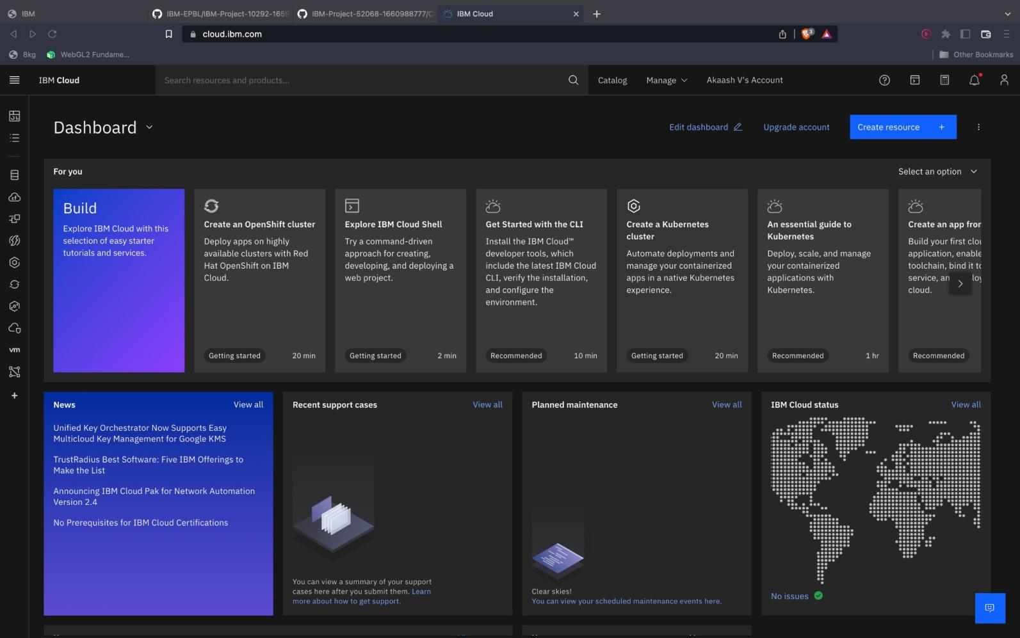Create IBM Cloud Account: